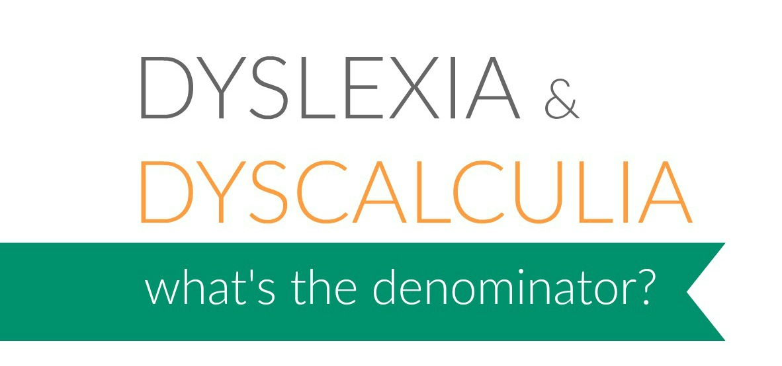
Certificate of Attendance

This is to certify that

attended the Square Pegs Conference
‘Dyslexia and Dyscalculia; what’s the denominator’?
on Saturday 7 October 2017 in Hobart.
The workshop content aligns to Australian Professional Standards for Teachers:
1.1 Physical, social and intelectual development and characteristics of students
1.2 Understand how students learn
1.5 Differentiate teaching to meet specific learning needs of students across the full range of abilities
1.6 Strategies to support full participation of students with disability
2.1 Content and teaching strategies of the teaching area
2.2 Content selection and organisation
2.5 Literacy and numeracy strategies
3.1 Establish challenging learning goals
3.2 Plan, structure and sequence learning programmes
3.3 Use a range of teaching strategies
3.5 Use effective classroom communication
3.6 Evaluation and improve teaching programmes
3.7 Engage parents/carers in the educative process
4.1 Support student participation
5.1 Assess student learning
5.2 Provide feedback to students on their learning
5.4 Interpret student data
6.2 Engage in professional learning and improve practice
7.4 Engage with professional teaching networks and broader communities

And Disability Standards fror Education (2005)- working towards greater Understanding of Part 3 ‘Making reasonable adjustments’.

Dr Judith Hudson
C.Psych.AFBPsS. PhD. MEd BA. AMBDA
Ambassador: Square Pegs Dyslexia Support and Advocacy Inc.

