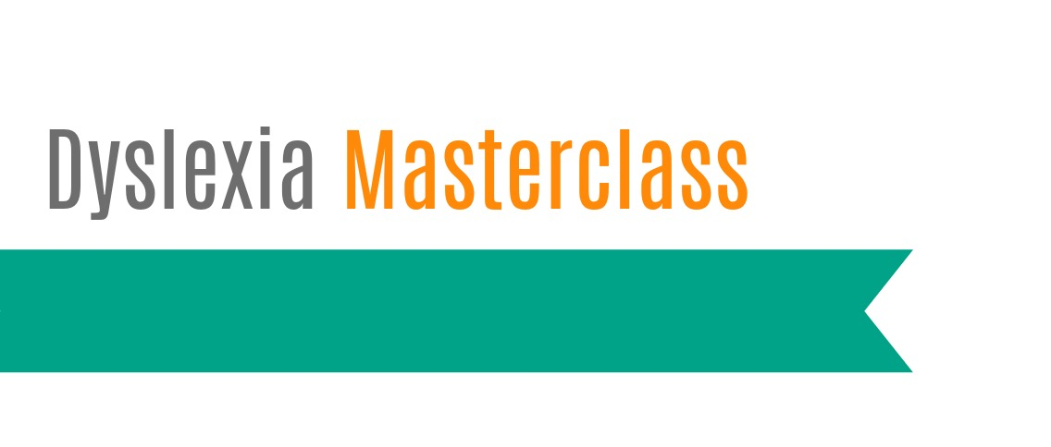
Certificate of Attendance

This is to certify that

attended the Square Pegs Masterclass delivered by Bill Hansbury & Sarah Asome
Strategies for dealing with dyslexia in the classroom
on Friday 6 October 2017.

The workshop content aligns to Australian Professional Standards for Teachers below:
1.1 Physical, social and intelectual development and characteristics of students
1.2 Understand how students learn
1.5 Differentiate teaching to meet specific learning needs of students across the full range of abilities
1.6 Strategies to support full participation of students with disability
2.1 Content and teaching strategies of the teaching area
2.2 Content selection and organisation
2.5 Literacy and numeracy strategies
3.1 Establish challenging learning goals
3.2 Plan, structure and sequence learning programmes
3.3 Use a range of teaching strategies
3.5 Use effective classroom communication
3.6 Evaluation and improve teaching programmes
3.7 Engage parents/carers in the educative process
4.1 Support student participation
5.1 Assess student learning
5.2 Provide feedback to students on their learning
5.4 Interpret student data
6.2 Engage in professional learning and improve practice
7.4 Engage with professional teaching networks and broader communities

Dr Judith Hudson
C.Psych.AFBPsS. PhD. MEd BA. AMBDA
Ambassador, Square Pegs Dyslexia Support and Advocacy Inc.
06.10.2017

